**Lab Assignment 3**

1. Create a webpage to display the following student table. A minimum of 6 student records must be available. Use inline css for the same.

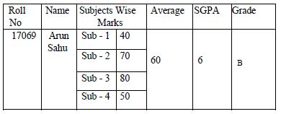

1. Design the following table using colspan and rowspan.

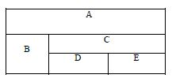

(solve any one question between qstn no 1 and 2)

1. Create a class ATM illustrating the functionality of ATM. Use switch case for the same.